**Тема: Shops and shopping**

**Мета**: повторити, активізувати і закріпити лексичний матеріал теми; практикувати учнів у діалогічному мовленні; формувати навички аудіювання та письма; сприяти розвиткові мовної здогадки; розвивати комунікативні вміння учнів, культуру мовлення; виховувати культуру спілкування, ввічливість.

**Обладнання:** підручник, комп’ютер, проектор, HO

**Тип уроку:** урок-пазл

**Хід  уроку**

**І. Підготовка до сприйняття іншомовного мовлення**

**1.** **Привітання**

«Hello songs»

**2. Повідомлення теми та мети уроку**

My dear friends! Today we are going to speak about different kinds of shops and what we can buy   there. We’ll recite poems, do some interesting tasks and then… Oh, then — it’s a secret.  So, let’s start.  Are you ready?

Pupils. Yes. We are ready.

**3.** **Уведення в іншомовну атмосферу**

1. Читання вірша

*Good morning sun, good morning sky.*

*“Good morning” – say together.*

*We like this day the best of all*

*And start the English lesson.*

2. Фонетична розминка

But today we have unusual lesson. Do you like to do puzzle? Look at the blackboard! You can see a puzzle. During our lesson we’ll do interesting task and open each from this six puzzles. Look at this picture. Who is this? Yes, it is Vicky. And today Vicky’s birthday. And we are going to greeting her and do the puzzle. At the end of the lesson we’ll see the picture. But what is it, it’s a secret. So, let’s begin!

**1 puzzle «Tongue-twister»**

Your old friend Mr. Tongue prepared the first task for you. There are sheets of paper with tongue-twisters on them. Your task is to find your partner with the same repeating sound in the tongue-twister. Move around the classroom and find your pair.

O.K. I see you’ve finished. Read your tongue-twisters and name the sounds.

[ʃ] Shy Shelly says she shall go shopping

Sheila sells shelled shrimps.

[s] Six crisp snacks.

She sells Swiss sweets.

[b] Blake the baker bakes black bread.

I bought a bit of baking powder and baked a batch of biscuits

[f] For fine fresh fish, phone Phil.

A fish-sauce shop's sure to sell fresh fish sauce.

Well done. But can you tell me what all these tongue-twisters are about? You are right. We can open the first puzzle.

**2.** **Основна частина уроку**

**1. Повторення лексичних одиниць**

1. *Mind Map*

- Do you like doing shopping?

**-** Where do you like to buy different things? Let’s make up the mind map.

shops

chemist’s sііі

baker’s

ё

ё

ё

butcher’ s

newsagent’s

dairy

department store

supermarket

I like to buy something at the **baker’s** (на дошці)

(Учні виходять до дошки, записують назву магазина і складають речення)

**2 puzzle «Wise box»**

And now let’s answer for some questions to open the next puzzle.

Well done. We can open the second puzzle.

**3.****Фізична та мовленнєва розминка**

**3 puzzle «Open, Close»**

To open our next puzzle you must have some rest. Let’s sing the song “Open, close”

**4. Розвиток навиків читання та розуміння прочитаного**

**4 puzzle «A Shopping Day»**

To open our next puzzle you must read the text «A Shopping Day» and then put the words in order according the text

**A Shopping Day**

Today is Saturday. This is the day when we do the shop­ping.

First we go to the baker's to get some bread. Then we buy some milk, butter, sour cream and cheese at the dairy. After that we go to the butcher's where we buy meat, sausages, ham or bacon. At the greengrocer’s we buy fruit and vegetables.

My favorite place to go is the toy store. It is very big and nice. There are many colorful toys there. I always ask my mum for a new toy or a puzzle.

The best place to do the shopping is the supermarket. But sometimes we go to the department store.

And now, let`s do the task on our computer

Test «A Shopping day»

Put the words in order:

1. greengrocer’s
2. department store
3. dairy
4. butcher's
5. supermarket
6. baker's
7. toy store

And we can open our forth puzzle.

***5. Аудіювання***

**5 puzzle «Hippoty Hop»**

To open our next puzzle I want to acquaintance you with my friend Hippoty.  He likes to go shopping very much. He does it every day. Listen to the song and say where and when he goes.

Кожен учень отримує карточку з назвою дня тижня, учні повинні почути в який магазин Хіппоті ходив в цей день і що він там купив.

**While-listening**

**T:** Match the shop and the day Hippoty was there.

**P1**: Hippoty went to the baker’s on Tuesday. He bought …

Well done, my young friends! And we can open our fifth puzzle

**Song "Hippoty Hop to the corner shop"**

Hippoty Hop to the corner shop,

To buy some sweets for Sunday;

Some for you,

Some for me,

Some for sister Sandy.

Hippoty Hop to the butcher’s shop,

To buy some meat for Monday;

Some for you,

Some for me,

Some for sister Sandy

Hippoty Hop to the baker’s shop,

To buy some bread for Tuesday;

Some for you,

Some for me,

Some for sister Sandy

Hippoty Hop to the grocer’s shop,

To buy some flour for Wednesday;

Some for you,

Some for me,

Some for sister Sandy

Hippoty Hop to the dairy shop,

To buy some butter for Thursday;

Some for you,

Some for me,

Some for sister Sandy

Hippoty Hop to the greengrocer’s shop,

To buy some apples for Friday;

Some for you,

Some for me,

Some for sister Sandy

Hippoty hop to the fishmonger’s shop

To buy some kippers for Saturday

Some for you,

Some for me,

Some for sister Sandy.

***6. Письмо***

**6 puzzle «Invitation»**

Look at this picture! Can you say me what is it? Yes, it is a basket. But to look what we have in this basket we must open our last puzzle. Do you remember that today’s Vicky’s birthday? I have very interesting invitation for you. But some words are missing. Can you guess what is missing in this note?

Dear friends,

Please, come to my birthday party on Tuesday, 11th of January at 10 o’clock at our school. There will be a balloon party

Vicky

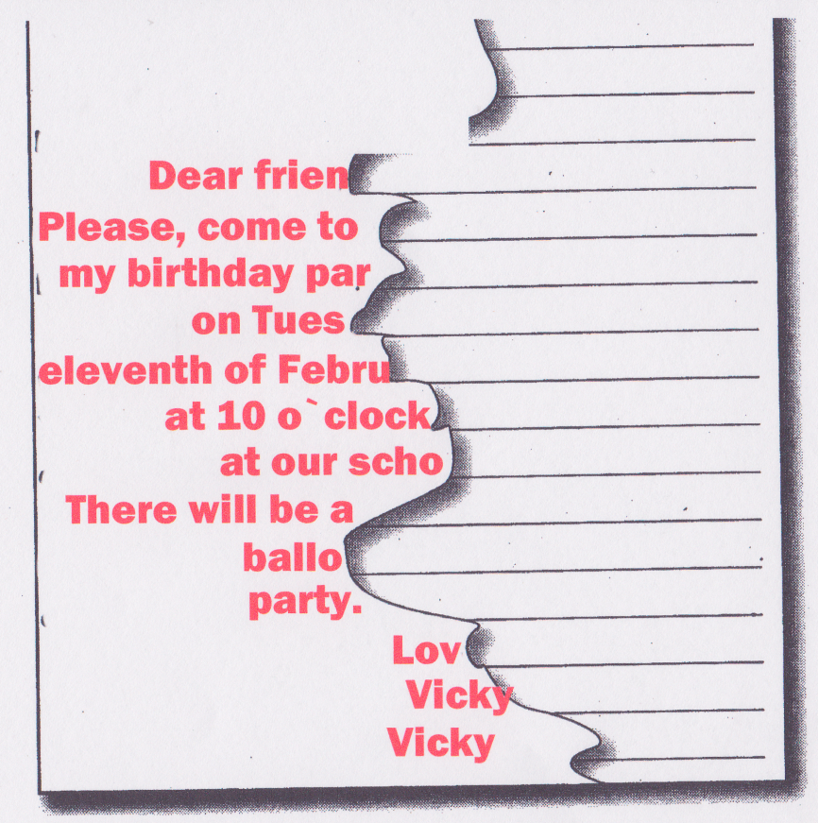

***7. Розвиток навиків діалогічного мовлення***

Look at this puzzle! We do it! But our basket is empty. And if you are going to the Vicky’s birthday party, we must bring her some present. And now image that you are in the department store and you want to buy some presents. Use the expressions from the blackboard and don’t forget the rule:

Let us try to be polite   
In everything we do  
Remember always to say “Please”  
And don’t forget “Thank you”!

Інсценізація діалогів

* книжка
* лялька
* кулька
* квіти
* цукерки
* апельсини
* пазли

**ІІІ. Заключна частина уроку**

1. ***Домашнє завдання***

Thank you, children. I am glad, that you have worked well today. And now take your daybooks and write down your homework, please. You have to make up your own dialogue «In the shop».

1. ***Підведення підсумків уроку***

I liked your work very much today. Your marks are … .

So. Our lesson is over. Stand up, please. Good bye.

*Good bye, teacher*

*Good bye, friends.*

*Good bye, classroom*

*Good bye, guests!*