Козир Світлана Іванівна,

вчитель англійської мови.

вчитель І категорії,

Йосипівський НВК

«Загальноосвітня школа І – ІІІ ступенів –

дошкільний навчальний заклад»

Урок розроблений за підручником О.Карп’юк «English», 4 клас

Тема: Минулі події

**Тема**. Travelling to the Kingdom of the Past Simple Tense.

**Мета.** Практикувати учнів у вживанні форми минулого часу дієслова to be в стверджувальних, питальних і заперечних реченнях; навчати мовлення, використовуючи конструкції минулого неозначеного часу; активізувати навчальні уміння і навички школярів; розвивати пам'ять, логічне мислення, мову, увагу учнів; виховувати цікавість до вивчення мови.

**Обладнання.** Підручник «English» 4 клас О.Карп’юк, комп’ютер, слайди, малюнки, картки для самостійної роботи, карта «The Kingdom of the Past Simple Tense».

**Тип уроку.** Урок-подорож

**Хід уроку**

**І. Підготовка до сприйняття іншомовного мовлення**

***1. Привітання***

Good morning, children!

I’m glad to see you!

***2. Повідомлення теми і мети уроку***

Today we continue our trip to the Kingdom of the Past Simple Tense. During our lesson you’ll revise what you know about irregular and regular verbs, practice in reading, speaking and listening.

Let’s start!

***3. Уведення в іншомовну атмосферу***

You have already got acquaintance with the Kingdom of the Past Simple Tense. Today we’ll have a trip to this Kingdom. But to enter there we must read this rhyme:

**Good morning, everyone!**

**It’s time to have some fun,**

**And we have some today**

**To write and read and play!**

And now let’s read this rhyme:

- loudly;

- in whisper;

- slowly;

- quickly.

Well done! You can enter the Kingdom and begin our trip.

**II. Основна частина уроку**

1. Практикування в вживанні минулого часу дієслова to be

a) повторення граматичного матеріалу: дієслово to be

And our first stop is the Town of Verb to Be. Tell me, please, what form does the verb to be have? (It has two forms: was and were) (слайд)

And now let’s see do you remember when do we use was and when were?

And let’s play the game **“Choose the right place”.** We have two aquariums. And let’s make two groups: the group of boys and the group of girls. Your task is to put fish in the correct aquarium.

Game **“Choose the right place”**

All right. Thanks for your work, (оцінювання)

b) Повторення граматичного матеріалу: дієслово to be: питальна і заперечна форми

Our next stop is the Town of Interrogative and Negative Sentences. To enter this town you must play very interesting game. But first let’s recollect how we make up these sentences:

Tom was at the cinema

Tom was not at the cinema

Was Tom at the cinema? (слайд)

How do we form negative sentence? (We put not after was)

How do we form interrogative sentence? (We put was on the first place)

Well done. Let’s play game **“Tick-tack-toe”.** The group of boys will be group “X” and the group of girls will be group “0”. You see a field with the numbers, and numbers mean some sentence. Choosing the number, you choose the sentence and you must make up either negative or interrogative sentence.

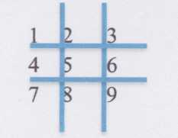

1. You were at the Zoo last week (?)

2. He was at his Granny (-)

3. They were at the hospital (?)

4. The weather was fine yesterday (?)

5. I was at the concert last Sunday (-)

6. She was at the library (-)

7. She was in the hotel (?)

8. They were at school yesterday (?)

9. The film was interesting (?)

The winner is group of... I give you for one smiler.

c) Порядок слів у реченні

We are still in the Town of interrogative and negative sentences. And I want that you recollect the order in the sentence and play the game **“Naughty Words”.** Please, choose your card and make up sentence. (1 smile for the right place)

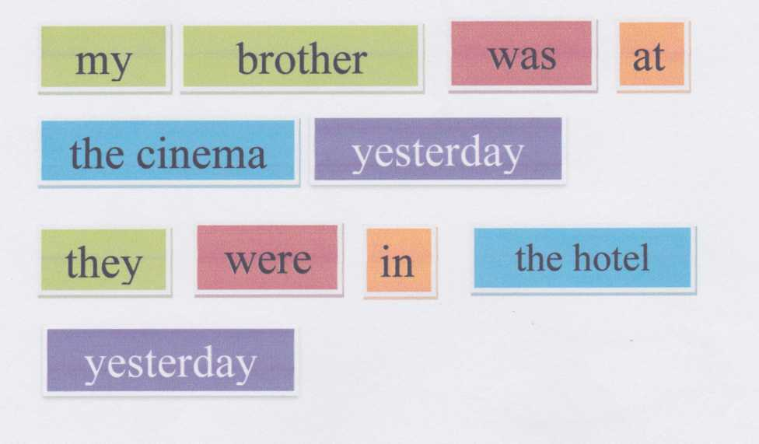

***2. Фізкультхвилинка***

To continue our trip we must cross the river. And for that let’s have some rest. Let’s sing the song “If you’re happy”

(пісня на екрані комп’ютера)

***3. Граматичний матеріал: минулий час правильних дієслів. Правила читання закінчення —ed.***

So, now we are at the land of regular verbs. And we in the town of ending -ed. Open your books on page 106. Look at the exercise 1. All these words tell us about the past events. But they read in different ways. First, the ending -ed read as [t] after voiceless consonants - let’s read the first column; as [d] - after voiced consonants - let’s read the second column; as [id] - after t or d - let’s read the third column.

Now? Let’s check up how you understand the rules of reading. Look at the blackboard, we can see the table. And you’ll see a word on the screen. Your task is to choose the right column for each word.

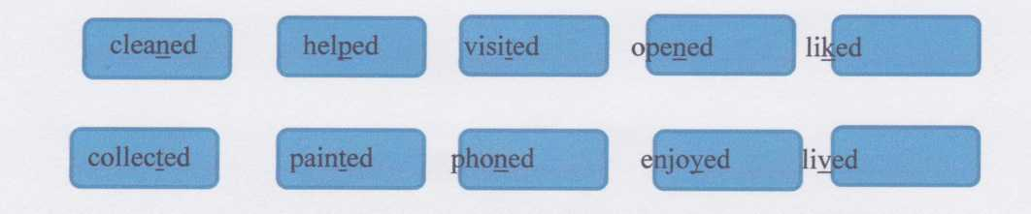

|  |  |  |
| --- | --- | --- |
| [t] | [d] | [id] |
|  |  |  |

***4. Пред`явлення тексту для читання***

And now time to read and write. Our next stop is the town of reading. We’ll read the text and do some interesting task. But first of all I’d like to ask you:

Where were you last Friday?

- visited my grandma;

- cooked dinner;

- cleaned the room;

- listening to music;

- played computer game;

- watched TV;

- helped you parents.

Last Friday I...

- reading “one by one”

- and now your task is to complete the sentence

HO1

Заповни пропуски правильним дієсловом у формі минулого часу

1. Bill and Taras in the streets.

2. Kate dinner.

3. Bill and Taras the rooms.

4. Kate to music.

5. Bill and Taras computer games with Nick and Vicky.

6. In the evening Taras and the Browns TV.

Your next task is answer the questions:

1. What day was yesterday?

2. Was the weather fine or bad?

3. Where were Bill and Taras?

4. Where were Bill’s parents in the daytime?

5. Where were the Browns yesterday?

6. Can you say what the film about?

***5. Пред’явлення тексту для аудіювання***

Well done. You may go on. And let’s go to our next stop. It’s a Town of Listening. I want that you listen to the text «Wendy Lewis» and say me what you have known about Wendy’s past life and about Wendy’s present life.

- аудіювання тексту «Wendy Lewis»

Wendy Lewis is twenty now. She is tall and beautiful. She has a short brown hair. But when she was young her hair was long. She lived with her parents in a big house in York. Now she lives and works in London. She has a job of an office manager now, and she lives in a small flat.

On Sundays Wendy likes to play tennis with her friends. But when she was at school she was a good basketball player.

|  |  |
| --- | --- |
| Розподіли слова на два стовпчики: ті, що стосуються сучасного життя Венді, і  ті, що стосуються її минулого  short hair, basketball, York, big house, long hair, London, office, small flat, tennis,  school | |
| Now | Many years ago |
| She lives in ... | She lived in ... |
| She lives in ... | She lived in ... |
| She has... | She had... |
| She works at... | She went to... |
| She plays ... | She played ... |

***6. Розвиток умінь мовлення***

We are on our last stop? And this is the Town of Speaking. Your home task for today was to make up story about your last Friday and draw a picture. While speaking try answer the questions:

Where were you? What did you do last Friday? How did you like it?

Last Friday I was at the cinema. I watched the film. It was interesting. I liked it.

Last Friday I was at the concert. I listened to music. It was fantastic. I liked it.

Last Friday I was at the home. I played computer games. It was interesting. I liked it.

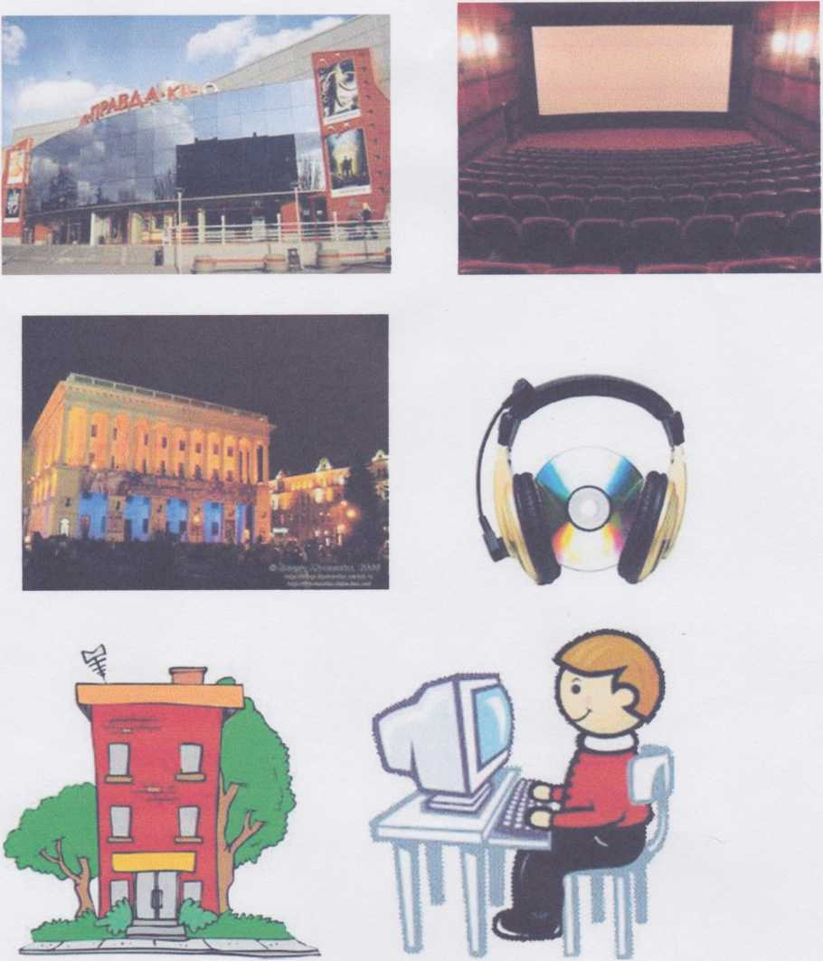

**III. Заключна частина уроку.**

1. Домашнє завдання

Ех. 5, р 107. On the next lesson you must prepare the Kate’s list of things that

she did on Monday.

2. Підведення підсумків уроку

- оцінювання учнів

- “Grammar game”

То finish our trip we must do the next task. On the screen of the computer you’ll see some words. Your task is to make up sentences using the Past Simple Tense.

1. Polly/at the library

2. Cindy and Wendy/at the cinema

3. John and Bill/ in the shop

4. Sam /in the zoo

Thanks for the lesson. Let’s finish our lesson with the rhyme

**Our work is done and it’s time to go,**

**We had a busy day.**

**We’ll see you on tomorrow’s day!**

**Good-bye!**